Stakeholder Analysis (and Management) in Projects
Petra Pistor

What is a stakeholder?
Stakeholders are all persons or person groups, who have an interest in your project, can affect your project or can be affected by your project. They can be internal or external to the organisation or the project. Stakeholders are an important entity to keep in mind when implementing a project, since they could influence a project heavily. Examples or project stakeholders are: client, funder, manager of institution, line manager, political parties, lobby organisations, legislation etc. The list is potentially endless.

Why stakeholder analysis?
The (cultural, political, social etc.) environment, within which a project takes place, plays an important role for the project planning and execution, because it will have an influence on the project. Stakeholders are part of this environment. A stakeholder analysis can help to:
- identify influences and risks,
- find supporters and opponents,
- identify chances and potential conflicts,
- come up with a communication and marketing strategy.

How can project stakeholders be identified?
To identify the project stakeholders, some simple questions have to be answered:
- Who has an interest in the project? Does this person/do these persons have a positive or negative attitude towards the project?
- Who will be positively or negatively affected by the project?
- Who can support or hinder the project?
- Who would wish to have what form of information about the project?
- From whom does the project team wish to have (or needs) information?

How can stakeholders of a project be managed?
The reason for identifying project stakeholders and analysing their attitude towards the project, the next important questions to answer are:
- How will the project team react to the stakeholders?
- How can the stakeholders be engaged?
- How can a positive attitude towards the project be supported or maintained?

To find out about the project stakeholders and the respective strategy to deal with them, the following matrix can be helpful (see also the screencast 5_4: Project stakeholders):
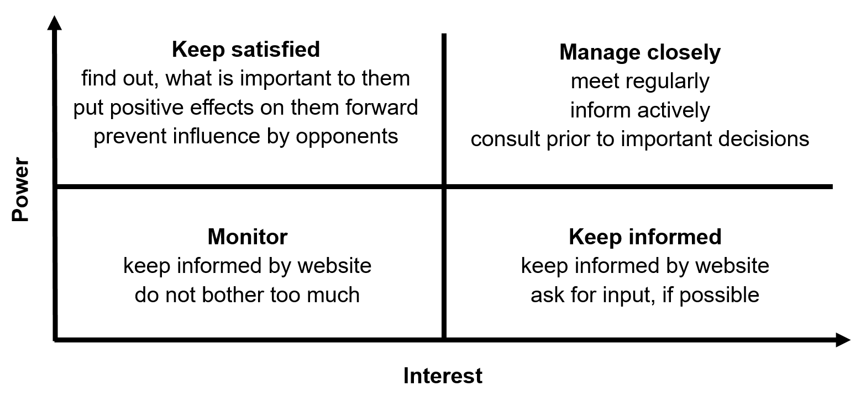
Illustration 1: Stakeholder Matrix.

On page 3 you find a chart that can help to assign a strategy of how to deal with those stakeholders, you need to or want to bother about.

In a nutshell
- A stakeholder analysis will help you to plan your project and it is part of risk management.
- The identification and analysis of stakeholders is best be done with the entire project team.
- A stakeholder analysis is the first step to come up with a communication and marketing strategy for your project.
- As a rule of thumb on how to deal with stakeholders: Be nice! Be transparent! Engage!
- A comprehensive stakeholder analysis is more important for larger-scale projects with high strategic relevance.

Stakeholder List

Name / Function / Position | Positive Impact  How could the stakeholder profit from the project? | Negative impact  How could the stakeholder be affected negatively by the project? | Support  How could the stakeholder support the project? | Opposition  How could the stakeholder hinder project progress? | Strategy  How will the project team react to the stakeholder?

